F/ACV Challenge

5G GrayScale Data

Mobile Net:

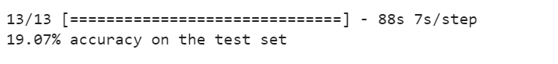

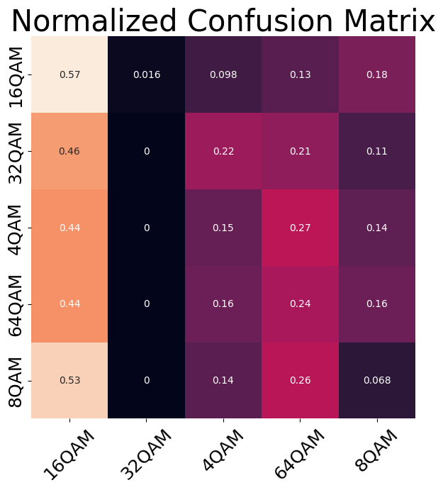

With data augmentation

